भारत मौसम विज्ञान विभाग |  | India Meteorological Department
Friday 22nd May 2026 (01st Jyaistha 1948 Saka)
Summary of observations recorded at 0830 hours IST: The Northern Limit of Monsoon continues to pass through 6°N/70°E, 6°N/75°E, 7°N/80°E, 9°N/85°E, 12°N/90°E, 14°N/93°E, 16°N/96°E and 17.5°N/98°E. Conditions are favourable for further advance of southwest monsoon into some more parts of southeast Arabian Sea, Comorin Area, southwest and southeast Bay of Bengal, remaining parts of Andaman Sea, and some more parts of eastcentral Bay of Bengal during next 2-3 days. The Western disturbance as a trough seen as a cyclonic circulation over north Pakistan & neighbourhood at 3.1 km above m. s. l. with a trough aloft in middle and upper tropospheric westerlies with its axis at 7.6 km above m. s. l. roughly along Long. 71°E to the north of Lat. 28°N. The upper air cyclonic circulation over north Haryana & neighbourhood lay over northwest Uttar Pradesh & neighbourhood and extended upto 1.5 km above m. s. l. The upper air cyclonic circulation over south coastal Odisha and neighbourhood lay over interior Odisha & neighbourhood and extended upto 1.5 km above m. s. l. An upper air cyclonic circulation lay over central Assam & neighbourhood at 1.5 km above m. s. l. An upper air cyclonic circulation lay over Southeast Bay of Bengal & neighbourhood at 3.1 km above m. s. l. An upper air cyclonic circulation lay over southeast Arabian Sea & neighbourhood at 3.1 km above m. s. l. A trough ran from the upper air cyclonic circulation over Southeast Arabian Sea to Comorin area across Kerala and south Tamil Nadu at 3.1 km above m. s. l. The trough ran from the upper air cyclonic circulation over northwest Uttar Pradesh to the upper air cyclonic circulation over interior Odisha across East Uttar Pradesh and Chhattisgarh extending upto 1.5 km above m. s. l. The trough from East Uttar Pradesh to south coastal Odisha merged with the above trough. An upper air cyclonic circulation lay over eastcentral Arabian Sea & neighbourhood at 1730 hrs IST of yesterday evening. It persisted and extended upto 1.5 km above m. s. l. at 0830 hrs IST of today. The upper air cyclonic circulation over Punjab & neighbourhood became less marked. The upper air cyclonic circulation over East Uttar Pradesh & neighbourhood became less marked. The trough in westerlies ran roughly along Long. 89°E to the north of Lat. 20°N became less marked. The trough from central Bay of Bengal to Tamil Nadu across southwest Bay of Bengal became less marked. An upper air cyclonic circulation lay over north Tamil Nadu & neighbourhood at 0.9 km above m. s. l. at 2000 hrs IST of yesterday night. It became less marked at 0830 hrs IST of today. The upper air cyclonic circulation over coastal Bangladesh and neighbourhood became less marked.
Maximum Temperature Departures (as on 21-05-2026): markedly above normal (> 5.1°C) at many places over East Uttar Pradesh, Himachal Pradesh, Coastal Andhra Pradesh & Yanam and Telangana; at most places over West Uttar Pradesh, East Madhya Pradesh and Chhattisgarh; at few places over West Madhya Pradesh; at isolated places over East Rajasthan, Vidarbha and Tamil Nadu, Puducherry & Karaikal. appreciably above normal (3.1°C to 5.0°C) at many places over Marathwada; at few places over Rayalaseema; at isolated places over Gujarat Region, Saurashtra & Kutch, Konkan & Goa and North Interior Karnataka. above normal (1.6°C to 3.0°C) at isolated places over Madhya Maharashtra. near normal (-1.5°C to 1.5°C) at most places over Coastal Karnataka, South Interior Karnataka, Kerala & Mahe and Lakshadweep. The highest maximum temperature of 47.6°C was reported at Banda (Uttar Pradesh).
Hailstorm occurred at isolated places over South Interior Karnataka.
Thunderstorm accompanied with Squally/Gusty winds with speed reaching 80-120 kmph prevailed at isolated places over Assam & Meghalaya & South Interior Karnataka; with speed reaching 50-80 kmph prevailed at isolated places over Marathwada, Bihar, Odisha, Tamil Nadu and with speed reaching 40-50 kmph prevailed at isolated places over Madhya Maharashtra, Coastal Andhra Pradesh, Kutch, Madhya Pradesh, Uttar Pradesh, Jammu-Kashmir, Punjab and Haryana.
Heat wave to severe heat wave conditions prevailed in few pockets over East Uttar Pradesh & Vidarbha; heat wave conditions in many pockets of Haryana Chandigarh & Delhi and Himachal Pradesh; some pockets of East Madhya Pradesh; in isolated pockets of Uttarakhand, Punjab, West Uttar Pradesh, Chhattisgarh & Coastal Andhra Pradesh.
Warn night conditions prevailed in isolated pockets over Punjab, Uttar Pradesh, East Madhya Pradesh, Vidarbha.
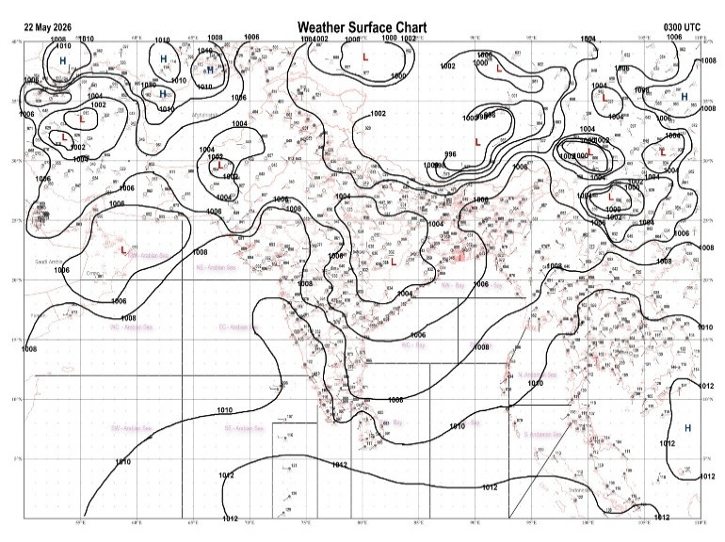 | 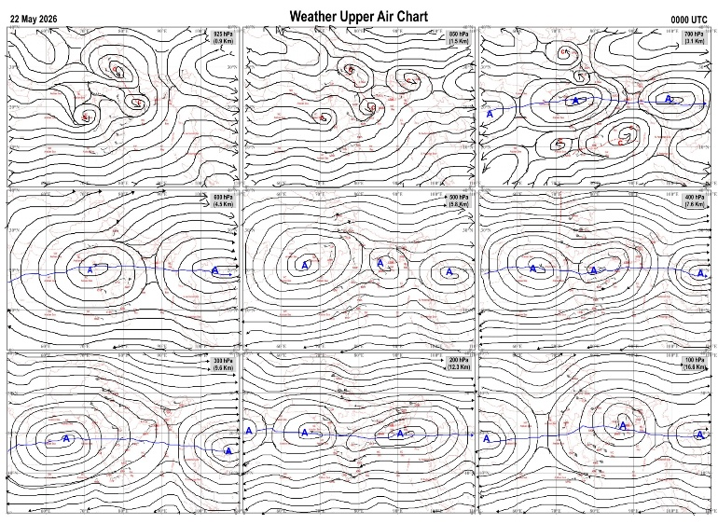
Fig.1. Analysed surface chart based on 03z observation | Fig.2. Analysed upper air chart based on 00z observation
Dr. S.D.Sanap
Scientist ‘D’
CR & S Office, Pune  Issued at 1245 hrs. IST |  | Weather Forecasting Division  CR&S, Pune

Indian regions | Realised rainfall (chief amount in cm during past 24 hrs):
East | a few places: Nagaland-Manipur-Mizoram-Tripura and Sub-Himalayan West Bengal & Sikkim+  isolated places: Arunachal Pradesh, Assam & Meghalaya+, Gangetic West Bengal, Odisha, Jharkhand and Bihar+  Jhanjharpur 9.5, Bahalpur 7.8, Lakhnaur 7.1, Sankos tea estate 6.7, Khumluwang ARG 5.7, Newlands tea garden 5.4, Balurghat 3.8, Kokrajhar & Ashapara AWS 3.5 each, Jajpur 2.6, Akhuapada 2.4, Dhubri IMD 1.2, Jamtara 0.8, Kohima 0.6, Darbhanga 0.5, Luchipur 0.4, Daporizo AWS & Mukto ARG 0.3 each, Durgapur, Cuttack & Sikatia 0.2 each.
North | many places: Jammu-Kashmir and Ladakh  isolated places: Uttarakhand◆, Haryana◆, Punjab and Himachal Pradesh  dry weather: Uttar Pradesh and Rajasthan  Nowgam 2.3, Sonemarg dual AWS 1.8, Kupwara 1.2, Kukumsheri AWS 0.7, Malikpur 0.6, Dhariwal irr & Keylong 0.5 each, Bangana r 0.4, Joshimath 0.2.
Central | dry weather: Madhya Pradesh, Vidarbha and Chhattisgarh
Peninsula | many places: Rayalaseema+ and Kerala#  a few places: coastal Karnataka, north interior Karnataka and south interior Karnataka+  isolated places: Konkan & Goa◆, Marathwada, coastal Andhra Pradesh, Telangana and Tamil Nadu  dry weather: Gujarat State and Madhya Maharashtra  Mavelikara 23.4, Kayamkulam ARG 21.2, Y n hoskote 8.8, Anantpur 7.3, Kozhikode 6.7, Bengaluru city 5.8, Ammapettai 5.4, Penu konda 4.9, Gooty & Davanagere PTO 4.6 each, Paiyur AWS & Bellatti 4.4 each, Sindgi 2.9, Shakti Nagar & Sulya 2.6 each, Cumbum & Damaragidda 1.9 each, Achampeta 1.6, Vepada 1.3, Dharamapuri 1.2, Kalaburgi 1.1, Kota 0.8, Dharashiv IMD parttime 0.7, Umarga 0.3, Nellore 0.2, Dabolim n.a.s. navy & Nanded IMD parttime 0.1 each.
Islands | a few places: Andaman & Nicobar and Lakshadweep  Maya bandar 2.2, Nancowry 1.1, Agathi 0.4, Hut bay 0.2.
Table-2 Forecast / warnings (distribution of rain / thundershowers) for 7 days (valid from time of origin upto 0830 hrs IST of next day)
Sr N. |  | Sub-division Name | Day 1 | Day 2 | Day 3 | Day 4 | Day 5 | Day 6 | Day 7 | Sr. No. | Sub-division Name | Day 1 | Day 2 | Day 3 | Day 4 | Day 5 | Day 6 | Day 7
 |  |  | 21 May | 22 May | 23 May | 24 May | 25 May | 26 May | 27 May |  |  | 21 May | 22 May | 23 May | 24 May | 25 May | 26 May | 27 May
 | 1 | Andaman Nicobar Islands | W  | W  | W  | W  | W | W  | W | 19 | west Madhya Pradesh | D + | D + | D + | D + | D + | D + | D+
 | 2 | Arunachal Pradesh | F +  | W ++  | W ++  | W +  | W +  | F + | F | 20 | east Madhya Pradesh | I + | D + | D + | D + | D + | D + | D +
 | 3 | Assam-Meghalaya | W +  | W ++  | W ++  | W ++  | W +  | F + | F + | 21 | Gujarat region | D | D | D | D | D | D | D
 | 4 | Nagaland-Manipur-Mizoram-Tripura | F +  | F +  | F +  | S  | S  | S | S | 22 | Saurashtra and Kutch | D | D | D | D | D | D | D
 | 5 | Sub Him West Bengal/Sikkim | W ++  | W++ | W+ | W +  | W + | W | F | 23 | Konkan and Goa | I  | I  | I | I | I | D | D
 | 6 | Gangetic West Bengal | I  + | I  + | I  + | I  + | I  + | S  | S  | 24 | Madhya Maharashtra | I  | I  | I | I | I | D | D
 | 7 | Odisha | I  + | I  + | I  + | I  + | I  + | I | I | 25 | Marathwada | I  | I  | I | I | D | D | D
 | 8 | Jharkhand | I  + | I  + | I  + | I  + | S  + | S  | S  | 26 | Vidarbha | D + | D + | D + | D + | D + | D + | D +
 | 9 | Bihar | I  + | I  + | I  + | I +  | I  | I  | I  | 27 | Chhattisgarh | D + | D + | D + | D + | I + | I | I
 | 10 | east Uttar Pradesh | D + | D + | D + | D + | D + | I + | I + | 28 | Coastal Andhra Pradesh and Yanam | I + | I  + | I + | D  + | I  + | I | I
 | 11 | west Uttar Pradesh | D + | D + | D + | D + | D + | D + | D + | 29 | Telangana | I+ | I  + | D + | D + | D + | D | D
 | 12 | Uttarakhand | S  | S  | I | I | I + | I + | I + | 30 | Rayalaseema | F + | F +  | S  | S  | I  | I | I
 | 13 | Haryana,Chandigarh and Delhi | I  + | D + | D + | D + | D + | D + | I + | 31 | Tamil Nadu, Puducherry and Karaikal | I++ | I +  | S+ | I +  | I+ | I | I
 | 14 | Punjab | I  + | I+ | D + | D + | D + | D + | I + | 32 | Coastal Karnataka | S  | S  | S  | S  | S  | F | F
 | 15 | Himachal Pradesh | F  | S | I | I | D + | D + | I + | 33 | North interior Karnataka | S+ | S +  | S  | I  | I  | S | S
 | 16 | Jammu-Kashmir and Ladakh | F  | S  | S  | S  | D + | D + | S + | 34 | South interior Karnataka | F + | F +  | F+ | S  | S  | S | S
 | 17 | west Rajasthan | I+ | D + | D + | D + | D + | D + | D + | 35 | Kerala and Mahe | W++ | W +  | W+ | W+ | W+ | W + | W +
 | 18 | east Rajasthan | D + | D + | D + | D + | D + | D + | D + | 36 | Lakshadweep | W+ | W +  | W+ | W+ | W+ | W | W
Legends: D = Dry I =isolated S = Scattered F = Fairly widespread W = Widespread #= heavy to very heavy rain at a few places with extremely heavy rain at isolated places+++= heavy rain at a few places with very heavy rain at isoIated places++= heavy to very heavy rainfall @=isolated exceptionally heavy rainfall+ = heavy rain ●/*= rain or snow ♦ = very light rain ≡=fog = thunderstorm with lightning =Squall / Gusty / gale / strong wind -=cold wave/cold day + = heat wave/warm night/hot and humid weather =Duststorm =ground frost = Hail.

Fig. 4: Districtwise warnings for five days for Maharashtra State
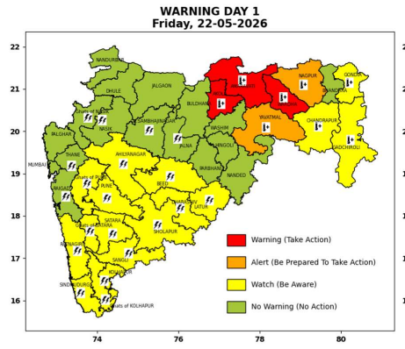 | 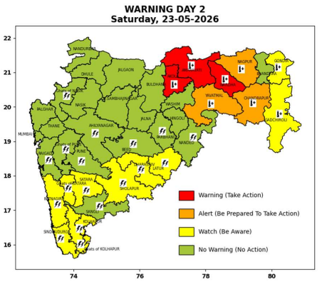 | 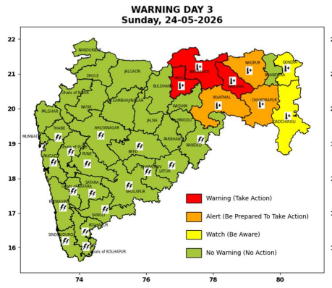 | 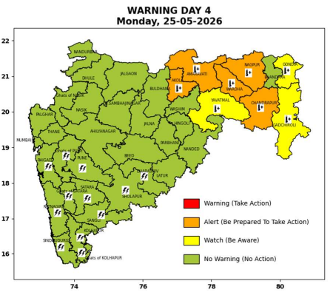 | 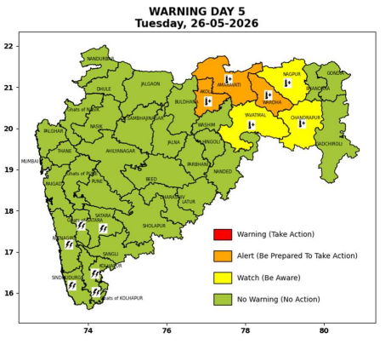

Pune, Lohegaon and Pashan observations at 0830 hrs. IST of Today
 | Temperature (°C) |  |  |  |  | Humidity (%) |  |  |  | Rainfall (mm)
 | Max.  past  24 hrs | Dep.  from  normal | Min.  past  24 hrs. | Dep.  from  normal | Dry  Bulb | At 0830 hrs. IST | Dep.  From  normal | At 1730  hrs. IST of ‘y’day | Dep.  from  normal | Past  24 hrs. | Since  1st March | Dep.  from  normal
PNE | 38.2 | 1.6 | 25.3 | 1.6 | 28.2 | 66 | 3 | 42 | 2 | 0.0 | 92.8 | 60.9
PSN | 38.5 | - | 24.4 | - | 27.8 | 70 | - | 45 | - | 0.0 | - | -
LHG | 40.0 | 4.0 | 27.5 | 6.5 | 30.8 | 51 | -12 | 28 | -11 | 0.0 | 91.4 | 51.8

 |  |  |  |  |  |  | Local (Pune and neighbourhood) forecast
Max./Min. Temperature (°C) |  |  |  |  |  |  |  |  | Weather
Date | Pune | Pashan | Lohegaon | Chinchwad | Lavale | Magarpatta | NDA | Koregoan park
22/05/26 | 37 / 25.3* | 38 / 24.4* | 40 / 27.5* | 37 / 26.0* | 37 / 22.5* | 40 / 26.8* | 37 / 24.7* | 40 / 26.9* | Mainly clear sky becoming partly cloudy sky towards afternoon or evening. Thunderstorm with lightning, light to moderate rain very likely.
23/05/26 | 40 / 25 | 40 / 24 | 42 / 27 | 38 / 26 | 39 / 23 | 42 / 27 | 39 / 25 | 42 / 27 | Mainly clear sky becoming partly cloudy sky towards afternoon or evening.
24/05/26 | 40 / 24 | 40 / 23 | 42 / 26 | 39 / 25 | 39 / 22 | 42 / 26 | 39 / 24 | 42 / 26 | Mainly clear sky becoming partly cloudy sky towards afternoon or evening.
25/05/26 | 39 / 24 | 39 / 23 | 41 / 26 | 39 / 25 | 38 / 22 | 41 / 26 | 38 / 24 | 41 / 26 | Mainly clear sky becoming partly cloudy sky towards afternoon or evening.
26/05/26 | 38 / 25 | 38 / 24 | 40 / 27 | 38 / 26 | 37 / 23 | 40 / 27 | 37 / 25 | 40 / 27 | Mainly clear sky becoming partly cloudy sky towards afternoon or evening.
27/05/26 | 39 / 25 | 39 / 24 | 41 / 27 | 37 / 26 | 38 / 23 | 41 / 27 | 38 / 25 | 41 / 27 | Mainly clear sky becoming partly cloudy sky towards afternoon or evening.
28/05/26 | 39 / 25 | 39 / 24 | 41 / 27 | 38 / 26 | 38 / 23 | 41 / 27 | 38 / 25 | 41 / 27 | Mainly clear sky becoming partly cloudy sky towards afternoon or evening.
Rainfall Distribution |  |  |  |  | Rainfall Categories | Rainfall (mm) | Cloud condition |  | Rainfall Intensity | Range
Widespread (W) | 76-100% |  |  |  | Very Light rain | Trace to 2.4 mm | Mainly clear sky | 1-2 oktas | Light Spell | 1 cm/hr
 |  |  |  |  | Light rain | 2.5 to 15.5 mm | Partly cloudy sky | 3-4 oktas | Moderate Spell | 1-2 cm/hr
Fairly Widespread (FW) | 51 – 75% |  |  |  | Moderate rain | 15.6 to 64.4 mm | Generally cloudy sky | 5-7 oktas | Intense Spell | 2-3 cm/hr
Scattered (S) | 26 – 50% |  |  |  | Heavy rain | 64.5 to 115.5 mm | Overcast | 8 oktas | Very Intense Spell | 3-5 cm/hr
Isolated (I) | 1 – 25% |  |  |  | Very heavy rain | 115.6 to 204.4 mm |  |  | Extremely Intense Spell | 5-10 cm/hr
Dry (D) | No Rain |  |  |  | Extremely heavy rain | ≥ 204.5 mm |  |  | Cloudburst | > 10 cm/hr
Probability Terms in %: |  |  |  |  | Heavy snow | 6.5 to 11.5 cms water equivalent of rain
unlikely | < 25 |  |  |  | Very heavy snow | 11.6 to 20.4 cms water equivalent of rain
likely | between 25 50
very likely | between 51 75
most likely | >75
* = realized temperature
Mumbai (Colaba) |  |  |  | Nagpur (AP)
Date 2026 | T max °C | T min °C | Weather | T max °C | T min °C | Weather
22/05/26 | 34 | 28 | Clear sky. | 46 | 29 | Heat Wave and warm night. Heat Wave.
23/05/26 | 34 | 28 | Clear sky. | 46 | 26 | Heat Wave and warm night. Heat Wave.
24/05/26 | 34 | 27 | Clear sky. | 46 | 26 | Heat Wave and warm night. Heat Wave.
25/05/26 | 34 | 27 | Clear sky. | 45 | 27 | Heat Wave.
26/05/26 | 35 | 27 | Clear sky. | 45 | 26 | Heat Wave.
27/05/26 | 35 | 27 | Clear sky. | 44 | 26 | Mainly clear sky.
28/05/26 | 34 | 27 | Clear sky. | 44 | 26 | Mainly clear sky.

